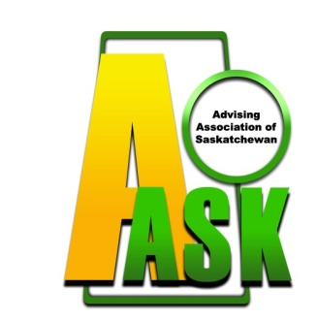
Advising Association of Saskatchewan (AASK)
2021 ADVISOR-CON
PROPOSAL SUBMISSION FORM

Contact Presenter
Name:
Institution/Employer:
Office Address:
City: Prov: Postal Code:
Office Phone: Email:
List Additional Presenters and their institution if applicable:
Title of Session:
All sessions will be one hour in length and will be delivered online through Zoom or similar software.
Session Format □ Workshop □ Facilitated Discussion □ Speakers Panel □ Presentation
□ Other:
Program Abstract: (max. 150 words) (if selected, this abstract will appear in the conference program)

Detailed Session Description: (max. 300 words)

Learning Outcomes & Theoretical Foundation: (max. 300 words)

I understand that presenters will:
- Register for ADVIOR-CON and pay the registration fee
  - Co-presenters attending only for their session will have their fee waived
- Not be paid an honorarium
- Submit any address, name or presentation information changes before October 1, 2021

Submit completed proposals to aask@skadvisors.ca by September 1st 2021.

